Chapter 18, Solution 46.

Determine the Fourier transform of i_{o}(t) in the circuit of Fig. 18.48.

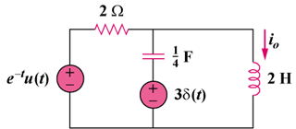

Figure 18.48
For Prob. 18.46.

Solution

2H jω2
3

The circuit in the frequency domain is shown below:

I_{o}(ω)

2 Ω

V_{o}
j2ω

–j4/ω

1/(1+jω)

+
−

3

+
−

At node V_{o}, KCL gives

I_{o}(ω) =

